SPRING CORE AND MAVEN

Exercise 1: Configuring a Basic Spring Application

Java.com.library.main.LibraryManagement.java

package com.library.main;

import com.library.service.BookService;
import org.springframework.context.ApplicationContext;
import org.springframework.context.support.ClassPathXmlApplicationContext;
import java.util.List;

/**
* LibraryManagementApp — Application Entry Point.
*
* Loads the Spring ApplicationContext from XML configuration.
* Retrieves beans managed by Spring IoC and tests all operations.
*
* Spring IoC Flow:
* XML Config → ApplicationContext → Bean Creation
* → Dependency Injection → Bean Ready to Use
*/
public class LibraryManagementApp {

public static void main(String[] args) {

System.out.println("╔══════════════════════════════════════════╗");
System.out.println("║ Library Management System — Spring ║");
System.out.println("╚══════════════════════════════════════════╝");

// ── Load Spring ApplicationContext from XML ──
ApplicationContext context =
new ClassPathXmlApplicationContext("applicationContext.xml");

System.out.println("\n[Spring] ApplicationContext loaded successfully!");
System.out.println("[Spring] Beans initialized by IoC Container.\n");

// ── Retrieve BookService bean from Spring container ──
BookService bookService = context.getBean("bookService", BookService.class);

// ══════════════════════════════════════════
// OPERATION 1: Fetch all books
// ══════════════════════════════════════════
System.out.println("\n── All Books in Library ──");
List<String> books = bookService.getAllBooks();
books.forEach(book -> System.out.println(" 📖 " + book));

// ══════════════════════════════════════════
// OPERATION 2: Find book by ID
// ══════════════════════════════════════════
System.out.println("\n── Find Book by ID ──");
System.out.println(" ID 2 → " + bookService.findBookById(2));
System.out.println(" ID 99 → " + bookService.findBookById(99));
System.out.println(" ID -1 → " + bookService.findBookById(-1));

// ══════════════════════════════════════════
// OPERATION 3: Add a new book
// ══════════════════════════════════════════
System.out.println("\n── Add New Book ──");
System.out.println(" " + bookService.addBook(5,
"Effective Java — Joshua Bloch"));

// ══════════════════════════════════════════
// OPERATION 4: Total count after addition
// ══════════════════════════════════════════
System.out.println("\n── Library Stats ──");
System.out.println(" Total Books: " + bookService.getTotalBooks());
System.out.println(" Is Empty: " + bookService.isLibraryEmpty());

// ══════════════════════════════════════════
// OPERATION 5: Remove a book
// ══════════════════════════════════════════
System.out.println("\n── Remove Book ──");
System.out.println(" " + bookService.removeBook(1));
System.out.println(" " + bookService.removeBook(99));

// ══════════════════════════════════════════
// OPERATION 6: Final state
// ══════════════════════════════════════════
System.out.println("\n── Final Library State ──");
bookService.getAllBooks()
.forEach(book -> System.out.println(" 📖 " + book));

// ── Close Spring context (releases all bean resources) ──
((ClassPathXmlApplicationContext) context).close();

System.out.println("\n╔══════════════════════════════════════════╗");
System.out.println("║ Application Closed Successfully ║");
System.out.println("╚══════════════════════════════════════════╝");
}
}

Java.com.library.repository.BookRepository.java
package com.library.repository;

import java.util.ArrayList;
import java.util.HashMap;
import java.util.List;
import java.util.Map;

/**
* BookRepository — Data Access Layer.
*
* Responsible for all data operations related to Books.
* In a real application, this would interact with a database.
* Here we simulate with an in-memory store (HashMap).
*
* Managed by Spring IoC Container as a singleton bean.
*/
public class BookRepository {

// Simulated in-memory database
private final Map<Integer, String> bookStore = new HashMap<>();

/**
* Initializes repository with sample data.
* In Spring, this acts as the bean's initial state.
*/
public BookRepository() {
bookStore.put(1, "Clean Code — Robert C. Martin");
bookStore.put(2, "The Pragmatic Programmer — Andrew Hunt");
bookStore.put(3, "Design Patterns — Gang of Four");
bookStore.put(4, "Spring in Action — Craig Walls");
System.out.println("[BookRepository] Bean initialized — " +
bookStore.size() + " books loaded into store.");
}

// Retrieves all books from the store
public List<String> getAllBooks() {
return new ArrayList<>(bookStore.values());
}

// Retrieves a book by its ID
public String getBookById(int id) {
return bookStore.getOrDefault(id, "Book not found for ID: " + id);
}

// Adds a new book to the store
public void addBook(int id, String title) {
bookStore.put(id, title);
System.out.println("[BookRepository] Book added: " + title);
}

// Removes a book by ID
public boolean removeBook(int id) {
if (bookStore.containsKey(id)) {
String removed = bookStore.remove(id);
System.out.println("[BookRepository] Book removed: " + removed);
return true;
}
return false;
}

// Returns total count of books
public int getTotalBooks() {
return bookStore.size();
}
}

Java.com.library.service.BookService.java

package com.library.service;

import com.library.repository.BookRepository;
import java.util.List;

/**
* BookService — Business Logic Layer.
*
* Handles all business rules for library operations.
* Depends on BookRepository for data access (injected by Spring).
*
* Demonstrates:
* ✔ Constructor Injection (recommended over field injection)
* ✔ Single Responsibility Principle
* ✔ Separation of concerns (service vs repository)
*/
public class BookService {

// Dependency injected by Spring IoC Container
private final BookRepository bookRepository;

/**
* Constructor Injection — Spring injects BookRepository bean here.
* This is the preferred injection method for mandatory dependencies.
*/
public BookService(BookRepository bookRepository) {
this.bookRepository = bookRepository;
System.out.println("[BookService] Bean initialized — " +
"BookRepository injected successfully.");
}

// Retrieves and displays all available books
public List<String> getAllBooks() {
List<String> books = bookRepository.getAllBooks();
System.out.println("[BookService] Fetching all books — " +
"Total: " + books.size());
return books;
}

// Finds a book by ID with business validation
public String findBookById(int id) {
if (id <= 0) {
return "Invalid Book ID — must be greater than 0";
}
return bookRepository.getBookById(id);
}

// Adds a book with business validation
public String addBook(int id, String title) {
if (title == null || title.trim().isEmpty()) {
return "Book title cannot be empty";
}
bookRepository.addBook(id, title);
return "Book added successfully: " + title;
}

// Removes a book with result feedback
public String removeBook(int id) {
boolean removed = bookRepository.removeBook(id);
return removed
? "Book with ID " + id + " removed successfully"
: "Book with ID " + id + " not found";
}

// Returns total book count
public int getTotalBooks() {
return bookRepository.getTotalBooks();
}

// Checks if library has books
public boolean isLibraryEmpty() {
return bookRepository.getTotalBooks() == 0;
}
}

Resources.applicationContext.xml

<?xml version="1.0" encoding="UTF-8"?>
<beans xmlns="http://www.springframework.org/schema/beans"
xmlns:xsi="http://www.w3.org/2001/XMLSchema-instance"
xsi:schemaLocation="
http://www.springframework.org/schema/beans
http://www.springframework.org/schema/beans/spring-beans.xsd">

<!--
Spring Bean Configuration — LibraryManagement
Defines beans managed by the Spring IoC Container.
Spring handles object creation, wiring, and lifecycle.
-->

<!-- BookRepository Bean — Data access layer -->
<bean id="bookRepository"
class="com.library.repository.BookRepository">
</bean>

<!-- BookService Bean — Business logic layer -->
<!-- Injects BookRepository via constructor injection -->
<bean id="bookService"
class="com.library.service.BookService">
<constructor-arg ref="bookRepository"/>
</bean>

</beans>

OUTPUT :

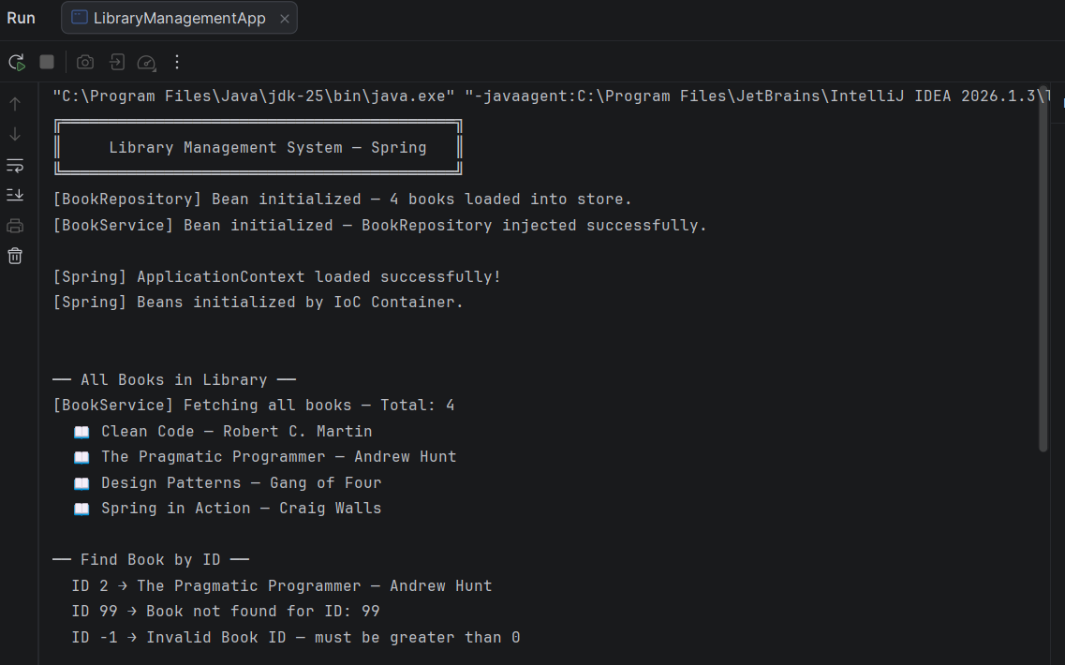
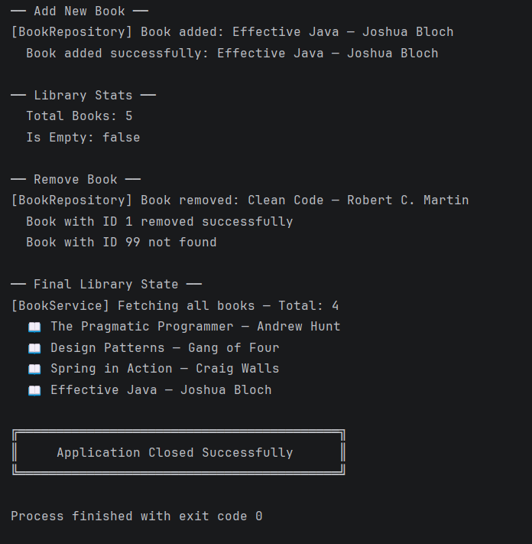

Exercise 2: Implementing Dependency Injection

src/main/resources/applicationContext.xml

<?xml version="1.0" encoding="UTF-8"?>
<beans xmlns="http://www.springframework.org/schema/beans"
xmlns:xsi="http://www.w3.org/2001/XMLSchema-instance"
xsi:schemaLocation="
http://www.springframework.org/schema/beans
http://www.springframework.org/schema/beans/spring-beans.xsd">

<!--
Spring Dependency Injection Configuration
Demonstrates TWO types of DI:
1. Setter Injection → bookService bean (this exercise)
2. Constructor Injection → bookServiceConstructor bean (bonus)
-->

<!-- ── BookRepository Bean — no dependencies ── -->
<bean id="bookRepository"
class="com.library.repository.BookRepository"/>

<!--
── BookService Bean — Setter Injection ──
Spring calls setBookRepository() automatically
after creating the BookService object.
property name="bookRepository" must match
the setter method: setBookRepository()
-->
<bean id="bookService"
class="com.library.service.BookService">
<property name="bookRepository" ref="bookRepository"/>
</bean>

<!--
── BookService Bean — Constructor Injection (Bonus) ──
Spring injects BookRepository via constructor.
Best practice for mandatory dependencies.
-->
<bean id="bookServiceConstructor"
class="com.library.service.BookService">
<constructor-arg ref="bookRepository"/>
</bean>

</beans>

src/main/java/com/library/service/BookService.java

package com.library.service;

import com.library.repository.BookRepository;
import java.util.List;

/**
* BookService — Business Logic Layer.
*
* Updated to support BOTH injection types:
* ✔ Setter Injection → setBookRepository() [this exercise]
* ✔ Constructor Injection → BookService(BookRepository) [Exercise 1]
*
* Spring IoC Container manages this bean's lifecycle
* and injects BookRepository automatically.
*/
public class BookService {

// Dependency managed by Spring IoC Container
private BookRepository bookRepository;

/**
* Default no-arg constructor.
* Required for Setter Injection —
* Spring first creates object, then calls setter.
*/
public BookService() {
System.out.println("[BookService] No-arg constructor called " +
"— ready for Setter Injection.");
}

/**
* Constructor Injection support.
* Spring uses this when <constructor-arg> is in XML config.
*/
public BookService(BookRepository bookRepository) {
this.bookRepository = bookRepository;
System.out.println("[BookService] Constructor Injection — " +
"BookRepository injected via constructor.");
}

/**
* ── SETTER INJECTION ──
* Spring calls this method automatically when
* <property name="bookRepository" ref="bookRepository"/>
* is defined in applicationContext.xml.
*
* Naming rule: setBookRepository()
* → property name must be "bookRepository" in XML
*/
public void setBookRepository(BookRepository bookRepository) {
this.bookRepository = bookRepository;
System.out.println("[BookService] Setter Injection — " +
"BookRepository injected via setBookRepository().");
}

// Getter — allows verification of injected dependency
public BookRepository getBookRepository() {
return bookRepository;
}

// ── Business Methods ──

public List<String> getAllBooks() {
validateDependency();
List<String> books = bookRepository.getAllBooks();
System.out.println("[BookService] getAllBooks() — Total: "
+ books.size());
return books;
}

public String findBookById(int id) {
validateDependency();
if (id <= 0) return "Invalid Book ID — must be greater than 0";
return bookRepository.getBookById(id);
}

public String addBook(int id, String title) {

validateDependency();
if (title == null || title.trim().isEmpty())
return "Book title cannot be empty";
bookRepository.addBook(id, title);
return "Book added successfully: " + title;
}

public String removeBook(int id) {
validateDependency();
boolean removed = bookRepository.removeBook(id);
return removed
? "Book with ID " + id + " removed successfully"
: "Book with ID " + id + " not found";
}

public int getTotalBooks() {
validateDependency();
return bookRepository.getTotalBooks();
}

/**
* Guards against null dependency —
* catches misconfigured Spring XML at runtime.
*/
private void validateDependency() {
if (bookRepository == null) {
throw new IllegalStateException(
"[BookService] BookRepository is null — " +
"check Spring XML configuration!");
}
}
}

src/main/java/com/library/repository/BookRepository.java

package com.library.repository;

import java.util.ArrayList;
import java.util.HashMap;
import java.util.List;
import java.util.Map;

public class BookRepository {

private final Map<Integer, String> bookStore = new HashMap<>();

public BookRepository() {
bookStore.put(1, "Clean Code — Robert C. Martin");
bookStore.put(2, "The Pragmatic Programmer — Andrew Hunt");
bookStore.put(3, "Design Patterns — Gang of Four");
bookStore.put(4, "Spring in Action — Craig Walls");
System.out.println("[BookRepository] Bean initialized — " +
bookStore.size() + " books loaded into store.");

}

public List<String> getAllBooks() {
return new ArrayList<>(bookStore.values());
}

public String getBookById(int id) {
return bookStore.getOrDefault(id, "Book not found for ID: " + id);
}

public void addBook(int id, String title) {
bookStore.put(id, title);
System.out.println("[BookRepository] Book added: " + title);
}

public boolean removeBook(int id) {
if (bookStore.containsKey(id)) {
String removed = bookStore.remove(id);
System.out.println("[BookRepository] Book removed: " + removed);
return true;
}
return false;
}

public int getTotalBooks() {
return bookStore.size();
}
}

src/main/java/com/library/main/LibraryManagementApp.java

package com.library.main;

import com.library.service.BookService;
import com.library.repository.BookRepository;
import org.springframework.context.ApplicationContext;
import org.springframework.context.support.ClassPathXmlApplicationContext;
import java.util.List;

/**
* LibraryManagementApp — Demonstrates Spring Dependency Injection.
*
* Verifies:
* ✔ Setter Injection via <property> tag in XML
* ✔ Constructor Injection via <constructor-arg> tag in XML
* ✔ Injected dependency is not null
* ✔ Business methods work correctly after injection
*/
public class LibraryManagementApp {

public static void main(String[] args) {

System.out.println("╔══════════════════════════════════════════════╗");
System.out.println("║ Library Management — Dependency Injection ║");
System.out.println("╚══════════════════════════════════════════════╝\n");

// ── Load Spring ApplicationContext ──
ApplicationContext context =
new ClassPathXmlApplicationContext("applicationContext.xml");

System.out.println("\n[Spring] ApplicationContext loaded successfully!\n");

// ════════════════════════════════════════════════
// VERIFY 1: Setter Injection
// ════════════════════════════════════════════════
System.out.println("══ Testing Setter Injection ══");
BookService bookService = context.getBean("bookService",
BookService.class);

// Verify dependency was injected
BookRepository injectedRepo = bookService.getBookRepository();
if (injectedRepo != null) {
System.out.println("[✔] Setter Injection SUCCESS — " +
"BookRepository is NOT null");
} else {
System.out.println("[✘] Setter Injection FAILED — " +
"BookRepository is null");
}

// ════════════════════════════════════════════════
// VERIFY 2: Constructor Injection
// ════════════════════════════════════════════════
System.out.println("\n══ Testing Constructor Injection ══");
BookService bookServiceConstructor = context.getBean(
"bookServiceConstructor", BookService.class);

BookRepository injectedRepo2 = bookServiceConstructor.getBookRepository();
if (injectedRepo2 != null) {
System.out.println("[✔] Constructor Injection SUCCESS — " +
"BookRepository is NOT null");
} else {
System.out.println("[✘] Constructor Injection FAILED — " +
"BookRepository is null");

}

// ════════════════════════════════════════════════
// VERIFY 3: Business operations via Setter Injection
// ════════════════════════════════════════════════
System.out.println("\n══ Business Operations (Setter Injected Bean) ══");

// Fetch all books
System.out.println("\n── All Books ──");
List<String> books = bookService.getAllBooks();
books.forEach(book -> System.out.println(" 📖 " + book));

// Find specific book
System.out.println("\n── Find Book by ID ──");
System.out.println(" ID 1 → " + bookService.findBookById(1));
System.out.println(" ID 5 → " + bookService.findBookById(5));

// Add new book
System.out.println("\n── Add Book ──");
System.out.println(" " + bookService.addBook(5,
"Effective Java — Joshua Bloch"));

// Remove a book
System.out.println("\n── Remove Book ──");
System.out.println(" " + bookService.removeBook(2));

// Final count
System.out.println("\n── Final Stats ──");
System.out.println(" Total Books: " + bookService.getTotalBooks());

// ── Close Spring context ──
((ClassPathXmlApplicationContext) context).close();

System.out.println("\n╔══════════════════════════════════════════════╗");
System.out.println("║ Application Closed Successfully ║");
System.out.println("╚══════════════════════════════════════════════╝");
}
}

OUTPUT :

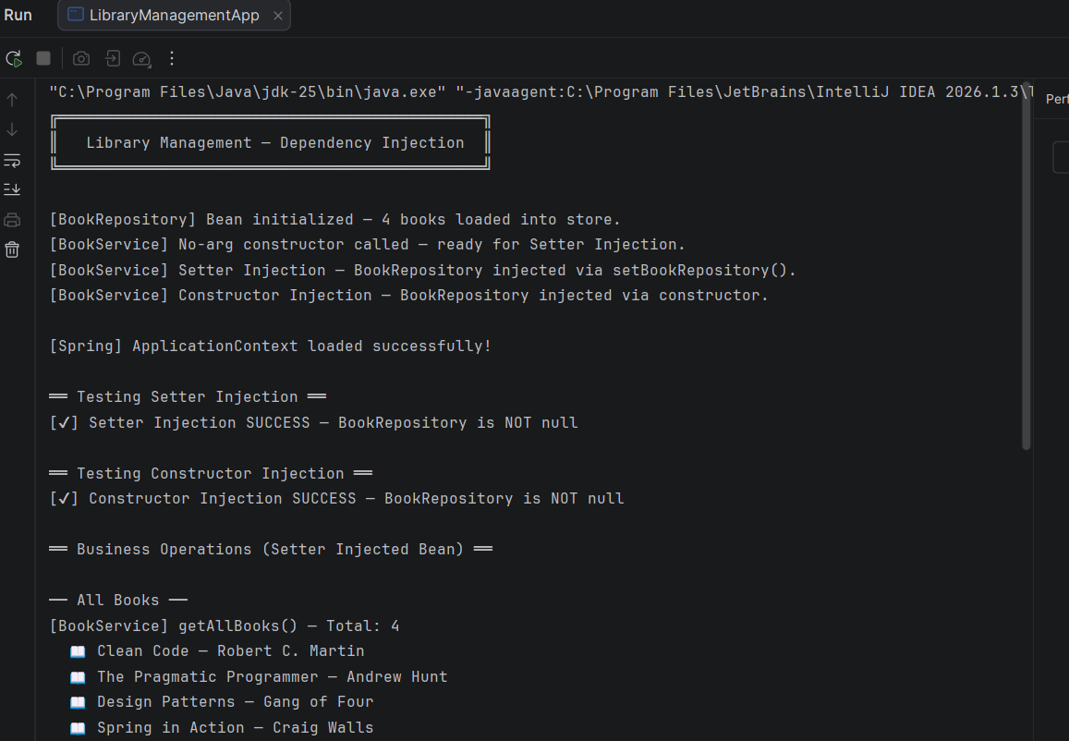

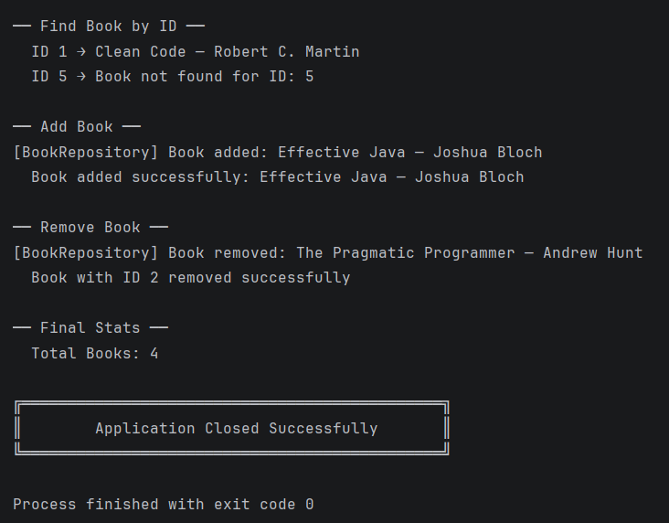

Exercise 4: Creating and Configuring a Maven Project

pom.xml

<?xml version="1.0" encoding="UTF-8"?>
<project xmlns="http://maven.apache.org/POM/4.0.0"
xmlns:xsi="http://www.w3.org/2001/XMLSchema-instance"
xsi:schemaLocation="http://maven.apache.org/POM/4.0.0
http://maven.apache.org/xsd/maven-4.0.0.xsd">

<modelVersion>4.0.0</modelVersion>

<!-- ── Project Identity ── -->
<groupId>com.library</groupId>
<artifactId>LibraryManagement</artifactId>
<version>1.0-SNAPSHOT</version>
<packaging>jar</packaging>
<name>LibraryManagement</name>
<description>
Library Management System — Spring Core, AOP, WebMVC
</description>

<!-- ── Centralized Version Management ── -->
<!--
Defining versions as properties avoids hardcoding
the same version string in multiple places.
To upgrade Spring, change only this one line.
-->
<properties>
<java.version>1.8</java.version>
<spring.version>5.3.20</spring.version>
<maven.compiler.source>1.8</maven.compiler.source>
<maven.compiler.target>1.8</maven.compiler.target>
<project.build.sourceEncoding>UTF-8</project.build.sourceEncoding>
</properties>

<dependencies>

<!--
── 1. Spring Context ──
Core Spring dependency — provides:
• ApplicationContext (IoC Container)
• Bean lifecycle management
• Dependency Injection (DI)
• Event publishing
-->
<dependency>
<groupId>org.springframework</groupId>
<artifactId>spring-context</artifactId>
<version>${spring.version}</version>
</dependency>

<!--
── 2. Spring AOP ──
Aspect-Oriented Programming — provides:
• Cross-cutting concerns (logging, security, transactions)
• @Aspect, @Before, @After, @Around annotations
• Proxy-based method interception
-->
<dependency>
<groupId>org.springframework</groupId>
<artifactId>spring-aop</artifactId>
<version>${spring.version}</version>
</dependency>

<!--
── 3. Spring WebMVC ──
Web layer — provides:
• DispatcherServlet (Front Controller)
• @Controller, @RequestMapping annotations
• REST API support (@RestController)
• View resolution (JSP, Thymeleaf)
-->
<dependency>
<groupId>org.springframework</groupId>
<artifactId>spring-webmvc</artifactId>
<version>${spring.version}</version>
</dependency>

<!--
── 4. Spring Core ──
Foundation for all Spring modules — provides:
• Core utilities and abstractions
• Resource loading
• Type conversion
-->
<dependency>
<groupId>org.springframework</groupId>
<artifactId>spring-core</artifactId>
<version>${spring.version}</version>
</dependency>

<!--
── 5. Spring Beans ──
Bean factory and XML configuration support — provides:
• BeanFactory
• XML bean definitions
• Setter and Constructor injection
-->
<dependency>
<groupId>org.springframework</groupId>
<artifactId>spring-beans</artifactId>
<version>${spring.version}</version>
</dependency>

<!--
── 6. Servlet API ──
Required by Spring WebMVC at compile time.
'provided' scope = available at compile time,
NOT bundled in final JAR (server provides it).
-->
<dependency>
<groupId>javax.servlet</groupId>
<artifactId>javax.servlet-api</artifactId>
<version>4.0.1</version>
<scope>provided</scope>
</dependency>

<!--
── 7. JUnit 4 ──
Unit testing framework.
'test' scope = only available during testing,
NOT included in production build.
-->
<dependency>
<groupId>junit</groupId>
<artifactId>junit</artifactId>
<version>4.13.2</version>
<scope>test</scope>
</dependency>

</dependencies>

<build>
<plugins>

<!--
── Maven Compiler Plugin ──
Tells Maven which Java version to use
for compiling source and target bytecode.
Set to Java 1.8 as required by the exercise.
-->
<plugin>
<groupId>org.apache.maven.plugins</groupId>
<artifactId>maven-compiler-plugin</artifactId>
<version>3.11.0</version>
<configuration>
<source>1.8</source>
<target>1.8</target>
<encoding>UTF-8</encoding>
</configuration>
</plugin>

<!--
── Maven Surefire Plugin ──
Controls how JUnit tests are discovered and run.
Ensures all test classes are picked up during build.
-->
<plugin>
<groupId>org.apache.maven.plugins</groupId>
<artifactId>maven-surefire-plugin</artifactId>
<version>3.1.2</version>
</plugin>

</plugins>
</build>

</project>

OUTPUT :

Step 1: maven changes loaded
Step 2: veryfying external dependencies

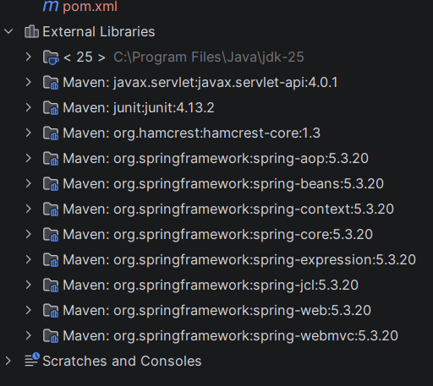

Step 3: verifying error
BUILD SUCCESS

Exercise 5: Configuring the Spring IoC Container

src/main/resources/applicationContext.xml

<?xml version="1.0" encoding="UTF-8"?>
<beans xmlns="http://www.springframework.org/schema/beans"
xmlns:xsi="http://www.w3.org/2001/XMLSchema-instance"
xsi:schemaLocation="
http://www.springframework.org/schema/beans
http://www.springframework.org/schema/beans/spring-beans.xsd">

<!--
Spring IoC Container Configuration
All beans defined here are managed by Spring.
Spring handles: creation, wiring, and lifecycle.
-->

<!-- ── BookRepository Bean ── -->
<!--
No dependencies — Spring creates this first.
Scope is singleton by default (one instance shared).
-->
<bean id="bookRepository"
class="com.library.repository.BookRepository"
scope="singleton">
</bean>

<!-- ── BookService Bean — Setter Injection ── -->
<!--
Spring creates BookService, then calls
setBookRepository() and injects bookRepository bean.
property name must match setter: setBookRepository()
-->
<bean id="bookService"
class="com.library.service.BookService"
scope="singleton">
<property name="bookRepository" ref="bookRepository"/>
</bean>

</beans>

src/main/java/com/library/service/BookService.java

package com.library.service;

import com.library.repository.BookRepository;
import java.util.List;

/**
* BookService — Business Logic Layer.
*
* Managed by Spring IoC as a singleton bean.
* BookRepository is injected via Setter Injection.
*
* IoC Principle:
* "Don't call us, we'll call you"
* Spring controls object creation and wiring —
* not the application code.
*/
public class BookService {

// Injected by Spring IoC Container
private BookRepository bookRepository;

/**
* No-arg constructor — required for Setter Injection.
* Spring first creates the object using this,
* then calls the setter to inject the dependency.
*/
public BookService() {
System.out.println("[BookService] Bean created by Spring IoC — "
+ "awaiting dependency injection.");
}

/**
* ── SETTER INJECTION ──
* Spring calls this automatically after bean creation.
* Maps to: <property name="bookRepository" ref="bookRepository"/>
*/
public void setBookRepository(BookRepository bookRepository) {
this.bookRepository = bookRepository;
System.out.println("[BookService] Setter Injection complete — "
+ "BookRepository wired successfully.");
}

// Getter — used to verify injection in main class
public BookRepository getBookRepository() {
return bookRepository;
}

// ── Business Methods ──

public List<String> getAllBooks() {
return bookRepository.getAllBooks();
}

public String findBookById(int id) {
if (id <= 0) return "Invalid ID — must be greater than 0";
return bookRepository.getBookById(id);
}

public String addBook(int id, String title) {
if (title == null || title.trim().isEmpty())
return "Title cannot be empty";
bookRepository.addBook(id, title);
return "Added successfully: " + title;
}

public String removeBook(int id) {
return bookRepository.removeBook(id)
? "Removed book with ID: " + id
: "Book not found with ID: " + id;
}

public int getTotalBooks() {
return bookRepository.getTotalBooks();
}
}

src/main/java/com/library/repository/BookRepository

package com.library.repository;

import java.util.ArrayList;
import java.util.HashMap;
import java.util.List;
import java.util.Map;

/**
* BookRepository — Data Access Layer.
*
* Managed by Spring IoC as a singleton bean.
* Simulates a database using an in-memory HashMap.
*/
public class BookRepository {

private final Map<Integer, String> bookStore = new HashMap<>();

public BookRepository() {
bookStore.put(1, "Clean Code — Robert C. Martin");
bookStore.put(2, "The Pragmatic Programmer — Andrew Hunt");
bookStore.put(3, "Design Patterns — Gang of Four");
bookStore.put(4, "Spring in Action — Craig Walls");
System.out.println("[BookRepository] Bean created by Spring IoC — "
+ bookStore.size() + " books loaded.");
}

public List<String> getAllBooks() {
return new ArrayList<>(bookStore.values());
}

public String getBookById(int id) {
return bookStore.getOrDefault(id, "Book not found for ID: " + id);
}

public void addBook(int id, String title) {
bookStore.put(id, title);
System.out.println("[BookRepository] Added: " + title);
}

public boolean removeBook(int id) {
if (bookStore.containsKey(id)) {
System.out.println("[BookRepository] Removed: "
+ bookStore.remove(id));
return true;
}
return false;
}

public int getTotalBooks() {
return bookStore.size();
}
}

src/main/java/com/library/main/LibraryManagementApp.java

package com.library.main;

import com.library.service.BookService;
import org.springframework.context.ApplicationContext;
import org.springframework.context.support.ClassPathXmlApplicationContext;
import java.util.List;

/**
* LibraryManagementApp — Entry Point.
*
* Demonstrates Spring IoC Container:
* ✔ Loading ApplicationContext from XML
* ✔ Retrieving beans managed by IoC
* ✔ Verifying Setter Injection worked
* ✔ Testing all business operations
*/
public class LibraryManagementApp {

public static void main(String[] args) {

System.out.println("╔══════════════════════════════════════════════╗");
System.out.println("║ Spring IoC Container — Library System ║");
System.out.println("╚══════════════════════════════════════════════╝\n");

// ── Step 1: Load Spring IoC Container from XML ──
ApplicationContext context =
new ClassPathXmlApplicationContext("applicationContext.xml");

System.out.println("\n[IoC] Container started — beans initialized!\n");

// ── Step 2: Retrieve BookService bean from IoC ──
BookService bookService =
context.getBean("bookService", BookService.class);

// ── Step 3: Verify Setter Injection ──
System.out.println("══ Dependency Injection Verification ══");
if (bookService.getBookRepository() != null) {
System.out.println("[✔] BookRepository injected — NOT null");
System.out.println("[✔] Setter Injection by Spring IoC — SUCCESS\n");
} else {
System.out.println("[✘] Injection FAILED — BookRepository is null\n");
}

// ── Step 4: Test all operations ──
System.out.println("══ All Books in Library ══");
List<String> books = bookService.getAllBooks();
books.forEach(b -> System.out.println(" 📖 " + b));

System.out.println("\n══ Find Book by ID ══");
System.out.println(" ID 1 → " + bookService.findBookById(1));
System.out.println(" ID 10 → " + bookService.findBookById(10));
System.out.println(" ID -1 → " + bookService.findBookById(-1));

System.out.println("\n══ Add New Book ══");
System.out.println(" " + bookService.addBook(5,
"Effective Java — Joshua Bloch"));

System.out.println("\n══ Remove Book ══");
System.out.println(" " + bookService.removeBook(3));
System.out.println(" " + bookService.removeBook(99));

System.out.println("\n══ Final Stats ══");
System.out.println(" Total Books: " + bookService.getTotalBooks());

// ── Step 5: Close IoC Container ──
((ClassPathXmlApplicationContext) context).close();

System.out.println("\n╔══════════════════════════════════════════════╗");
System.out.println("║ IoC Container Closed Successfully ║");
System.out.println("╚══════════════════════════════════════════════╝");
}
}

OUTPUT :

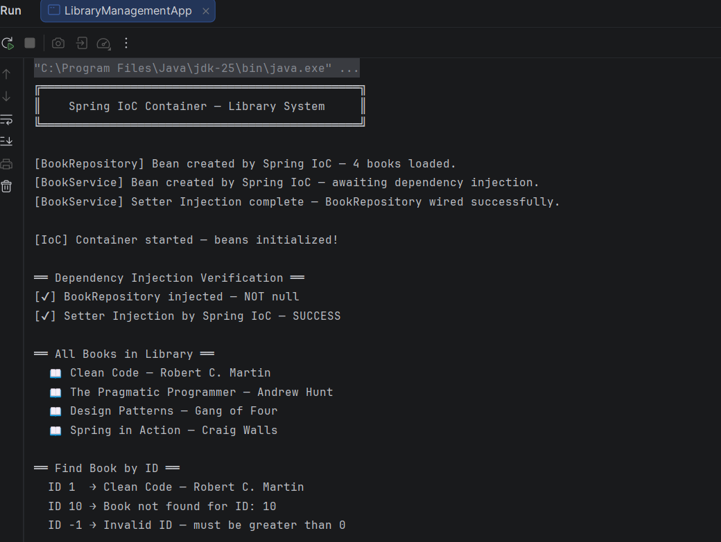

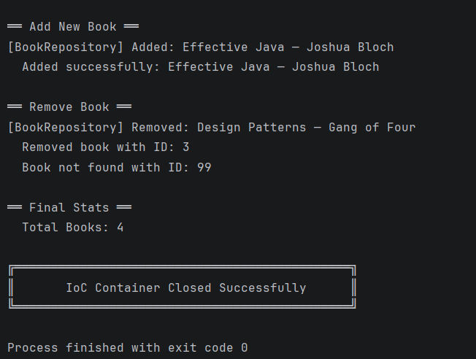

Exercise 7: Implementing Constructor and Setter Injection

src/main/resources/applicationContext.xml

<?xml version="1.0" encoding="UTF-8"?>
<beans xmlns="http://www.springframework.org/schema/beans"
xmlns:xsi="http://www.w3.org/2001/XMLSchema-instance"
xsi:schemaLocation="
http://www.springframework.org/schema/beans
http://www.springframework.org/schema/beans/spring-beans.xsd">

<!--
Exercise 7 — Constructor & Setter Injection
Two separate BookService beans to demonstrate both types.
-->

<!-- ── BookRepository Bean (shared by both services) ── -->
<bean id="bookRepository"
class="com.library.repository.BookRepository"/>

<!--
── Bean 1: Constructor Injection ──
Spring injects BookRepository via constructor.
Uses <constructor-arg> tag.
Best for: MANDATORY dependencies —
object cannot function without this dependency.
-->
<bean id="bookServiceConstructor"
class="com.library.service.BookService">
<constructor-arg ref="bookRepository"/>
<constructor-arg value="Constructor Injection Mode"/>
</bean>

<!--
── Bean 2: Setter Injection ──
Spring creates object first, then calls setter.
Uses <property> tag.
Best for: OPTIONAL dependencies —
object can exist without this dependency initially.
-->
<bean id="bookServiceSetter"
class="com.library.service.BookService">
<property name="bookRepository" ref="bookRepository"/>
<property name="serviceMode" value="Setter Injection Mode"/>
</bean>

</beans>

src/main/java/com/library/service/BookService.java

package com.library.service;

import com.library.repository.BookRepository;
import java.util.List;

/**
* BookService — Business Logic Layer.
*
* Supports BOTH injection types:
*
* ✔ Constructor Injection:
* Spring calls BookService(BookRepository, String)
* Dependency guaranteed at object creation time.
*
* ✔ Setter Injection:
* Spring calls no-arg constructor first,
* then calls setBookRepository() and setServiceMode().
* Dependency injected after object creation.
*/
public class BookService {

private BookRepository bookRepository;

// Describes which injection type was used
private String serviceMode;

// ════════════════════════════════════════════════
// Constructor Injection
// Maps to: <constructor-arg> in XML
// ════════════════════════════════════════════════

/**
* No-arg constructor — required for Setter Injection.
* Spring uses this when <property> tags are defined.
*/
public BookService() {
System.out.println("[BookService] No-arg constructor called "
+ "— Setter Injection path.");
}

/**
* Parameterized constructor — used for Constructor Injection.
* Spring uses this when <constructor-arg> tags are defined.
*
* @param bookRepository injected by Spring via <constructor-arg>
* @param serviceMode injected by Spring via <constructor-arg value>
*/
public BookService(BookRepository bookRepository, String serviceMode) {
this.bookRepository = bookRepository;
this.serviceMode = serviceMode;
System.out.println("[BookService] Constructor Injection — "
+ "BookRepository and serviceMode injected.");
}

// ════════════════════════════════════════════════
// Setter Injection
// Maps to: <property name="bookRepository"> in XML
// ════════════════════════════════════════════════

public void setBookRepository(BookRepository bookRepository) {
this.bookRepository = bookRepository;
System.out.println("[BookService] setBookRepository() called "
+ "— Setter Injection complete.");
}

public void setServiceMode(String serviceMode) {
this.serviceMode = serviceMode;
System.out.println("[BookService] setServiceMode() called "
+ "— value: " + serviceMode);
}

// ── Getters for verification ──
public BookRepository getBookRepository() { return bookRepository; }
public String getServiceMode() { return serviceMode; }

// ── Business Methods ──

public List<String> getAllBooks() {
validate();
return bookRepository.getAllBooks();
}

public String findBookById(int id) {
validate();
if (id <= 0) return "Invalid ID — must be greater than 0";
return bookRepository.getBookById(id);
}

public String addBook(int id, String title) {
validate();
if (title == null || title.trim().isEmpty())
return "Title cannot be empty";
bookRepository.addBook(id, title);
return "Added successfully: " + title;
}

public String removeBook(int id) {
validate();
return bookRepository.removeBook(id)
? "Removed book with ID: " + id
: "Book not found with ID: " + id;
}

public int getTotalBooks() {
validate();
return bookRepository.getTotalBooks();
}

// Guards against null dependency
private void validate() {
if (bookRepository == null)
throw new IllegalStateException(
"[BookService] BookRepository is null — check XML config!");
}
}

src/main/java/com/library/repository/BookRepository.java

package com.library.repository;

import java.util.ArrayList;
import java.util.HashMap;
import java.util.List;
import java.util.Map;

/**
* BookRepository — Data Access Layer.
* Singleton bean managed by Spring IoC Container.
*/
public class BookRepository {

private final Map<Integer, String> bookStore = new HashMap<>();

public BookRepository() {
bookStore.put(1, "Clean Code — Robert C. Martin");
bookStore.put(2, "The Pragmatic Programmer — Andrew Hunt");
bookStore.put(3, "Design Patterns — Gang of Four");
bookStore.put(4, "Spring in Action — Craig Walls");
System.out.println("[BookRepository] Bean created — "
+ bookStore.size() + " books loaded.");
}

public List<String> getAllBooks() {
return new ArrayList<>(bookStore.values());
}

public String getBookById(int id) {
return bookStore.getOrDefault(id,
"Book not found for ID: " + id);
}

public void addBook(int id, String title) {
bookStore.put(id, title);
System.out.println("[BookRepository] Added: " + title);
}

public boolean removeBook(int id) {
if (bookStore.containsKey(id)) {
System.out.println("[BookRepository] Removed: "
+ bookStore.remove(id));
return true;
}
return false;
}

public int getTotalBooks() {
return bookStore.size();
}
}

src/main/java/com/library/main/LibraryManagementApp.java

package com.library.main;

import com.library.service.BookService;
import org.springframework.context.ApplicationContext;
import org.springframework.context.support.ClassPathXmlApplicationContext;
import java.util.List;

/**
* LibraryManagementApp — Verifies Constructor & Setter Injection.
*
* ✔ Loads Spring ApplicationContext from XML
* ✔ Retrieves both injected beans
* ✔ Verifies dependencies are not null
* ✔ Runs business operations on both beans
*/
public class LibraryManagementApp {

public static void main(String[] args) {

System.out.println("╔══════════════════════════════════════════════════╗");
System.out.println("║ Exercise 7 — Constructor & Setter Injection ║");
System.out.println("╚══════════════════════════════════════════════════╝\n");

// ── Load Spring IoC Container ──
ApplicationContext context =
new ClassPathXmlApplicationContext("applicationContext.xml");

System.out.println("\n[Spring] IoC Container loaded successfully!\n");

// ════════════════════════════════════════════════
// TEST 1: Constructor Injection Bean
// ════════════════════════════════════════════════
System.out.println("╔══════════════════════════════════════╗");
System.out.println("║ Constructor Injection Bean ║");
System.out.println("╚══════════════════════════════════════╝");

BookService constructorBean = context.getBean(
"bookServiceConstructor", BookService.class);

// Verify injection
System.out.println("[✔] Mode : " + constructorBean.getServiceMode());

System.out.println("[✔] Repo null: " +
(constructorBean.getBookRepository() == null
? "NULL ✘" : "NOT NULL ✔"));

// Operations
System.out.println("\n── All Books ──");
constructorBean.getAllBooks()
.forEach(b -> System.out.println(" 📖 " + b));

System.out.println("\n── Find by ID ──");
System.out.println(" ID 2 → " + constructorBean.findBookById(2));

System.out.println("\n── Add Book ──");
System.out.println(" " + constructorBean.addBook(5,
"Effective Java — Joshua Bloch"));

// ════════════════════════════════════════════════
// TEST 2: Setter Injection Bean
// ════════════════════════════════════════════════
System.out.println("\n╔══════════════════════════════════════╗");
System.out.println("║ Setter Injection Bean ║");
System.out.println("╚══════════════════════════════════════╝");

BookService setterBean = context.getBean(
"bookServiceSetter", BookService.class);

// Verify injection
System.out.println("[✔] Mode : " + setterBean.getServiceMode());
System.out.println("[✔] Repo null: " +
(setterBean.getBookRepository() == null
? "NULL ✘" : "NOT NULL ✔"));

// Operations
System.out.println("\n── All Books ──");
setterBean.getAllBooks()
.forEach(b -> System.out.println(" 📖 " + b));

System.out.println("\n── Remove Book ──");
System.out.println(" " + setterBean.removeBook(1));
System.out.println(" " + setterBean.removeBook(99));

System.out.println("\n── Total Books ──");
System.out.println(" Count: " + setterBean.getTotalBooks());

// ════════════════════════════════════════════════
// SUMMARY
// ════════════════════════════════════════════════

System.out.println("\n╔══════════════════════════════════════╗");
System.out.println("║ Injection Summary ║");

System.out.println("╠══════════════════════════════════════╣");
System.out.println("║ Constructor Injection → ✔ SUCCESS ║");
System.out.println("║ Setter Injection → ✔ SUCCESS ║");
System.out.println("╚══════════════════════════════════════╝");

// ── Close Spring context ──
((ClassPathXmlApplicationContext) context).close();
System.out.println("\n[Spring] IoC Container closed.");
}
}

OUTPUT :

